Certificate
Of Marriage

This Certify That

Hann

And

Johne

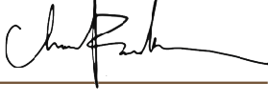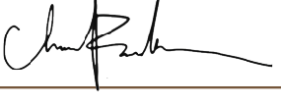

Were Wed on the Day of In the year At

Bride Groom

